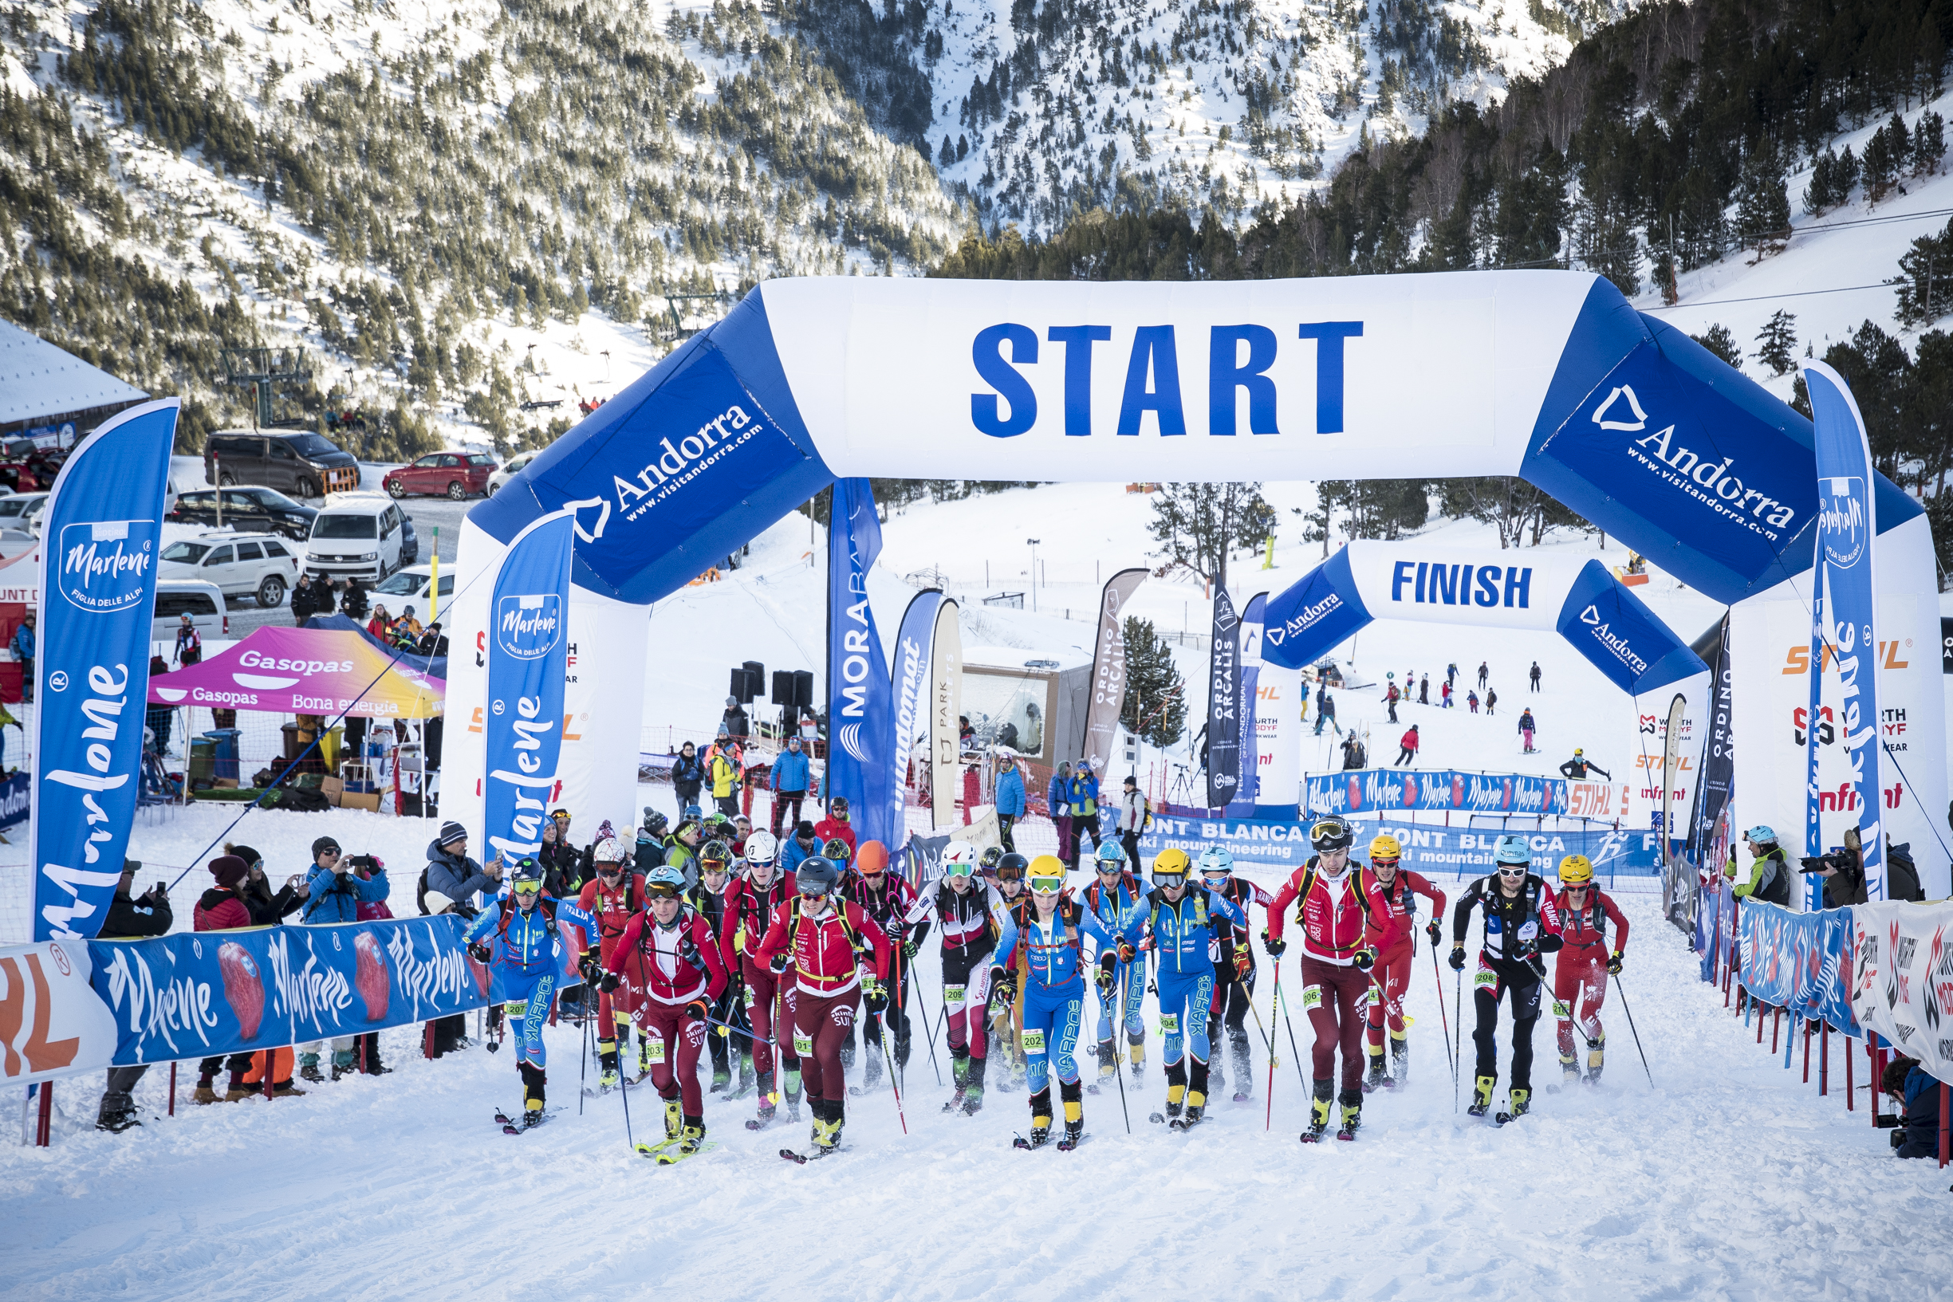
‘Event Name’ – 2022/23 season

Introduction
The starting point for improving the sustainability of a ski mountaineering race is to understand and analyze what environmental impacts each event has in a systematic and careful way, both from a broad perspective and with individual measurable metrics.
The ISMF must first complete an environmental diagnosis which will help to determine and characterize the most important aspects of sustainability of each race, even those over which there is no direct control, but we may have some influence.
This is a guide to help every ISMF Elite event become more sustainable. Section B should be filled out as a description about the impacts of the race on local flora and fauna. Section C is a green event checklist and discussion of items that can be implemented to make a race more sustainable. Each race director must fill out this report and return it to the ISMF Sustainability Commission by the end of the season. The more precise you are, the more efficient and useful our collective work will be. This document is a starting point and should be evaluated with your suggestions, so please let us know about any new item or modifications needed within the checklist.
Promoting sustainability is an opportunity to improve our environmental impact as well as streamline all organizational aspects. Sustainability is something that we will all benefit from, in both direct and secondary impacts of our actions.
For any questions concerning the use of this manual, feel free to contact giulia.avagnina@ismf-ski.org.

Some advice to fill out the Matrix:
- Before the race, define your plan
  - Just document the Planned Column for every Topic in each Theme
  - The accepted values are YES (We plan to work on that Topic), NO, DNA (This Topic does Not Apply to my event)
- During the Race measure the indicators
  - The indicator column announces what should be measured during the event (i.e.: Kgs of waste …)
  - It’s just an information column, and nothing must be reported in this column.
- After the race, report the measurements in the Matrix and estimate your accomplishment level
  - You should report in The Level Column an estimation of accomplishment: 0 (finally could not work on that Topic), 1 (Partially accomplished), 2 (the planned action was fully successful)
  - The comments should include all the eventual measurements and any comment you consider helpful for next editions or other races.

The topic of sustainability is an opportunity to improve in all organisational aspects and will bring many direct and indirect benefits.
For any questions concerning the use of this manual, feel free to contact giulia.avagnina@ismf-ski.org.

- A. GENERAL INFORMATION

- Basic Information about the event
General Information
Race name
Race location
Organizer
Dates
Number of competitors
Number of staff
Number of volunteers
Economic details
Total Cost
Insert a Photo of your event

- Economical Report
It’s important for LOCs and ISMF to achieve economically sustainable events.
Even if it’s not compulsory, we appreciate it if you can detail the following information:
- Budget of the event per areas
- Final financial result

B. Effects on Flora and Fauna

Ski mountaineering races are held in alpine environments with fragile wildlife and ecosystems. Most events are held within ski area boundaries which limits the impact to an area that has frequent human impact. In years past several races have ventured into the backcountry which requires obtaining permits and authorization from government and local authorities. However the impact on natural systems is greater in the backcountry due to the use of explosives for avalanche control and the inevitable waste left behind by accident. ISMF recommends staying within the resort boundaries, when possible, to avoid impacting natural habitat of local wildlife and conserving resources.

1. Describe the venue area and race course impacts on the landscape.
2. Describe the impacts of the event on Fauna and Flora.

C. Action Plan and Green Event Checklist

1. Race and Race Course: Ways to make the race course itself more sustainable and have less of an impact on the environment are discussed here. These include simple things such as reusing signs from years prior, making sure that signs do not blow away in the wind by securing them in the snow. Having an inventory of all materials used to not lose anything by the end of the weekend is highly recommended. ISMF recommends using an organic alternative to aniline dye, for marking the snow to reduce environmental impact. In addition, we suggest opting for lower impact explosives and cleaning up waste from explosives. Training volunteers and staff in sustainability measures will make these goals easier to achieve. ISMF hopes to leave the course in better condition when the race is over than before it began.
Action | Planned | Indicator | Accomplishment Level | Comments
The name tags or the plastic covers and/or the lanyards for them will be collected and reused at the end of the event.
The decoration materials and signs are reused or can be reused (e.g. compostable, recyclable).
The prizes (for the winners or the lottery) are services (vouchers) or gifts from regional or socially just production and/or from environmentally friendly or natural materials.
The plants used for the event (as decoration or as a gift) are regional and seasonal or fair-trade cut flowers or branches (e.g. spruce branches) in the pot.

Action | Planned | Indicator | Accomplishment Level | Comments
Ensure proper anchorage of signs and banners to prevent dispersal in strong winds.
Limit the use of fungible material to that which is strictly necessary.
Use color ties and flanges (preferably black) to stop them from getting lost in the snow.
Choose an organic based dye or alternative to the chemical aniline for course marking.
Opt for lower impact explosives (Ex. Goma-2 ECO, does not contain DNT and reduces emissions of nitrogen oxide and CO2 by almost 70%)
Rationalize the amount of explosives and limit the number of detonations to those that are strictly necessary
Cleaning and recovery of waste from explosions (fuse ends, cables, etc.) if needed.
Set penalties for competitors if they leave waste during a race (rules).
Provide volunteers and members of the organization with waste collection bags.
Provide areas to concentrate the public and prevent the dispersion of people around the circuit.
Methodical review and clean up once the race has been completed.
Control noise pollution to keep below 70 decibels.

2. Catering and Refreshments, Waste: ISMF recommends partnering with a local hotel or resort to help reduce the catering needed for events. When catering however, use reusable dishes and cutlery whenever possible. ISMF suggests using large containers for drink dispensing and calculating the amount of food n”eeded prior to the event to decrease waste. ISMF also recommends using local food when possible. The main goal is to reduce waste.
Action | Planned | Indicator | Accomplishment Level | Comments
The products intended for sale (e.g. handicrafts, merchandising items, food from direct sellers) were produced and processed in the region and are marked accordingly.
Detergents are used sparingly.
Cleaning agents contain vegetable surfactants or have been awarded the Ecolabel.
Soaps and detergents are bought in bulk.
There are enough well-marked containers for visitors to collect residual waste and recyclables (e.g. paper, glass, plastic) separately.
There are enough well-marked containers or collection points for the stand operators or employees for the separate collection of residual waste and recyclable materials (e.g. glass, paper, cardboard, organic waste).
Employees and visitors are informed about the waste separation and the reusable system, if available, and asked to separate the waste conscientiously.
The responsible staff is responsible for the proper separation and emptying of the waste bins, including the bins for visitors.

Action | Planned | Indicator | Accomplishment Level | Comments
Cooking oil and other problematic substances (e.g. batteries, chemicals) are collected separately.
The return of reusable tableware is secured (through a deposit system or through the service staff).
At least 50% of the required crockery (e.g. plates, glasses, mugs) and cutlery is reusable.
Most of the required crockery (e.g. plates, glasses, mugs) and cutlery is reusable crockery and cutlery:
Significantly more than 50% (of the required crockery and/or cutlery)
%100 (of the required crockery and cutlery)
The catering offered is carefully planned and needs-based purchasing is carried out in order to avoid surpluses and food waste.
At least half of the dishes on the menu (excluding desserts) are vegetarian (no meat products, no fish).
The products used are from controlled organic cultivation:
Some
More than a third
More than the half
100%
The products and ingredients used are regional.

Action | Planned | Indicator | Accomplishment Level | Comments
For unprocessed products, this means: produced in the region (e.g. apples). For processed products it means: the ingredients are produced and processed in the region (e.g. jam for donuts) and/or the products bear a seal of quality such as "Red Rooster", "Quality South Tyrol" or equivalent.
Some
More than a third
More than the half
100%
Products that do not grow in our latitudes due to the climatic conditions come from fair trade: Coffee, cocoa and other products such as bananas, sugar, chocolate, and spices.
Tap water (e.g. in carafes, canisters or from the village well) is provided free of charge for everyone.
Leftover food, drinks and ingredients are used or distributed or given to others for further use.
Mineral water, non-alcoholic beverages and beer are offered in reusable containers (barrels, reusable bottles), if available on the market.
Food is mainly bought from local producers or through local supply facilities.
The following information is given on the menu: “regional” or indication of origin organic product fair trade product.
Small portions are available on request.

Action | Planned | Indicator | Accomplishment Level | Comments
If disposable plates and/or cups are used, they are made of cardboard, preferably recycled cardboard.
All paper products in the catering area are made from recycled paper (e.g. kitchen roll, napkins).
Instead of portion packs (for ketchup, mustard, mayonnaise) bulk packs or dispensers are used.
The use of disposable aluminum coffee capsules is avoided.

3. Event Areas/Venue: ISMF hopes that events will leave as little of an impact as possible and be as efficient as possible. Efficiency includes reducing waste and water use. Reducing the use of electricity and our overall carbon footprint is important for achieving goals related to climate change measures. If possible ISMF encourages races to utilize renewable energy and offset carbon emissions with carbon credits or other measures.
Action | Planned | Indicator | Accomplishment Level | Comments
Superstructures and equipment (e.g. bar, tables, tents, stage) are rented, reused or recycled.
Those responsible at the event location are informed of the measures in the areas of water consumption, hygiene and cleaning and asked to implement the measures.
All paper products in the hygiene area are made from recycled paper (e.g. toilet paper, paper towels with the Blue Angel label).
The sanitary facilities and the kitchen have water-saving equipment (e.g. toilet quick flush, self-closing fittings).
Water-saving measures are implemented in the sanitary facilities and in the kitchen (e.g. training employees in how to use water and dishwashers).
Mobile toilet facilities are connected to the existing sewer system.
Event rooms are heated to a maximum of 20°C. The heating temperature is lowered at night.
Those responsible at the event location are made aware of the energy measures and asked to implement them.

Action | Planned | Indicator | Accomplishment Level | Comments
The amount of lighting is reduced to a minimum.
The devices, lighting, etc. remain switched on only as long as necessary.
The employees are trained in the energy-saving use of devices, lighting, heating, air conditioning, etc.
In the event area, energy-saving lamps (e.g. LED lamps) are predominantly used.
The electrical devices used are energy-efficient (e.g. energy efficiency class A).
The electricity requirement is covered by renewable energy sources (e.g. photovoltaics).
The energy used for heating and/or cooling comes from Renewable sources (e.g. wood, geothermal energy,...)
The energy used to heat the water comes from renewable sources (e.g. solar thermal).
The greenhouse gas emissions resulting from energy consumption are offset by donations for climate protection projects or a tree planting campaign.
Power is supplied from the public grid (not from diesel or petrol generators).
In order to avoid light pollution, intensive outdoor lighting and laser sky projectors are not used.
Any cleaning company used is committed to sustainability.

4. Communication/Marketing/Advertising: In years past races have reduced the amount of paper waste produced in promotion of the event by using digital advertising instead. In addition, reusing banners and flags will not only reduce waste but will also decrease procurement costs. ISMF recommends using recycled paper for any fliers or other materials needed. To help reduce the carbon footprint of the event, ISMF recommends using a drone to capture footage of the races rather than a helicopter.
Action | Planned | Indicator | Accomplishment Level | Comments
The print types are printed entirely on certified virgin fiber paper (FSC or PEFC certificate or Ecolabel).
Digital advertising options are used (e.g. homepage, newsletter, email, social networks):
The application is made both digitally and in printed form.
The application is exclusively digital (complete waiver of printed matter)
The print types are printed on recycled paper:
Partly on 100% recycled paper, partly on certified fresh fiber paper (FSC, PEFC, Ecolabel)
Entirely on 100% recycled paper (e.g. Blue Angel label)
The edition and number of pages of the printed matter is limited to what is necessary.
The printed materials (flyers, programmes, posters) are distributed in a targeted manner.
The documents for the visitors (e.g. conference documents) are made available in digital form, they are not printed out.

Action | Planned | Indicator | Accomplishment Level | Comments
Advertising materials (e.g. banners, flags, roll-ups) are reused.
The press documents will be made available digitally and will not be printed out.
The documents for the press and/or visitors are printed on both sides on recycled paper, the number of color prints is reduced. (Recycled) cardboard is used for the folders.
PVC-free material is used for new signs, banners and roll-up.
Reusable or large containers (e.g. reusable crates and containers, barrels, bulk packs) are predominantly used for the products and their transport.
The employees of the event are informed in advance about the GreenEvent initiative (workshop, meeting, guidelines, etc.), involved in the planning and asked to implement the measures.
The event is advertised as a GreenEvent (e.g. printed matter, website, press releases, social networks).
At the event, the most important implemented measures will be presented in at least one clearly visible place on the information poster.
At the event, the GreenEvent logo will be prominently displayed on menus, information stands, boards, posters, signs, etc.

Action | Planned | Indicator | Accomplishment Level | Comments
The GreenEvent initiative will be presented on the homepage and/or in the social networks and/or in the brochure of the event and the implemented measures will be listed.
At the beginning and/or at the end of the event (welcome, conclusion), reference is made to the orientation as a GreenEvent.

Action | Planned | Indicator | Accomplishment Level | Comments
Drones are used for videography rather than helicopters to reduce carbon emissions.

5. Transportation: Measures to reduce transportation emissions and costs include using electric vehicles for transport to/at the event and using public transportation when possible. In years past, race organizers have been able to rent electric vehicles or have them paid for by sponsors. ISMF recommends creating a plan for efficient use of groomers and snowmobiles to reduce emissions.

Action | Planned | Indicator | Accomplishment Level | Comments
The event location can be easily reached by bus, train, bicycle or on foot or by cable car/cable car.
The time of the event (beginning and end) is selected considering the timetable or a separate (shuttle) service will be set up. In advance, visitors receive information on bus and train timetables, the cycle path network, or other forms of environmentally friendly mobility (on the homepage, in the invitation, via e-mail or verbally/by telephone). Visitors are motivated by special incentives (e.g. free drink, reduced admission) to travel by bus, train, bicycle or other environmentally friendly alternatives.
There are shuttles,
which bring the athletes, guests or artists to the event location and pick them up again from there.
which bring the visitors and spectators to the event location and pick them up again from there.

Action | Planned | Indicator | Accomplishment Level | Comments
On the invitation, the homepage and in the e-mails there is a corresponding note "We ask that you arrive and depart in an environmentally friendly manner". There is a contact person on site (during the event) who provides information on environmentally friendly arrival and departure, or clearly visible information on environmentally friendly mobility offers (e.g. timetable, signage for the shuttle stop, carpooling).
A shared taxi can be called for travel to and from the event location. A ride-sharing exchange is set up or an existing one is used, or ride-sharing opportunities are arranged.
The accommodations for guests or participants (e.g. athletes, artists) are close to the event location or are well connected to public transport.
Employees and volunteers are encouraged to set an example and walk, cycle, or use public transport themselves, or carpool.

Action | Planned | Indicator | Accomplishment Level | Comments
The use of snowmobiles and groomers for transport of people is limited to the impacted area and stays on established track avoiding sensitive areas.
Transportation on the snow with snowmobiles and groomers uses petrol or electricity rather than diesel:
Less than 50%
50% or greater
100%

6. Social responsibility: As Ski Mountaineering grows and becomes an Olympic sport, it will be important to acknowledge the impact it has on climate change. The ISMF will join the UN Sport for Climate Action movement and in doing so must begin to focus on measures to reduce emissions and make the sport more sustainable overall. In addition, a focus on social responsibility within the race and on promotion of local charities is suggested.
Action | Planned | Indicator | Accomplishment Level | Comments
The greenhouse gas emissions caused by the journey to the race are offset by donations for climate protection projects or tree planting campaigns.
Propose to the teams and racers to compensate for their CO₂ travel emissions.
There will be no fireworks, rockets, firecrackers or similar except for use for avalanche control by professionals.
There is a marked parking space near the entrance for people with disabilities.
The seating and tables are arranged in such a way that people in wheelchairs, with walkers or prams can pass easily. Adequate seats with a good view are available for people in wheelchairs.
As part of the event, non-profit associations and organizations in the environmental and social sector are given the opportunity to present their activities and collect donations (e.g. in the form of a solidarity stand).
Other measures not listed in the checklist to improve sustainability and/or social measures are implemented. Count:

Action | Planned | Indicator | Accomplishment Level | Comments
Cooperation with the international association ISMF in relation to the topic of "sustainability" - we develop and present suggestions for improvement.
Meetings of the team mostly online - work with Google Docs to avoid unnecessary printouts.
Use scannable QR codes are used to avoid printed matter and to pass on information digitally

7. Conclusion: Please discuss here any comments you have or suggestions for future races and events.

- Conclusions & Goals for next editions
      - LOC Global auto-evaluation
Describe a global impression, difficulties found and good experiences concerning the sustainability implementation.
Make a global projection for future editions.

Name Name
LOC President LOC Sustainability Coordinator
Signature Signature

      - ISMF Global commentaries (reserved to ISMF Sustainable Commission)
Resume table per section considering the matrix responses.
Modify data in the graphics and get your values (Report values in Excel associated blue table).
Report calculated Values into table.

Chapter | Declared Intention | Achievement Evaluation
Totals | $$\frac{\sum{Planned=Yes}}{Total items-\sum{Planned=DNA}}$$  Reported in % format | $$\frac{\sum{level}*0,5}{Total items-\sum{Planned=DNA}}$$  Reported In % format
      - Circuit
      - Catering & Refreshment points
      - Event Areas
      - Communication
      - Mobility
      - Social Responsibility
Global

Any commentary or recommendation by the ISMF Sustainability Commission in the clear objective to improve organization’s quality.

Name Name
ISMF General Manager ISMF Sustainability Commission
Signature Signature

