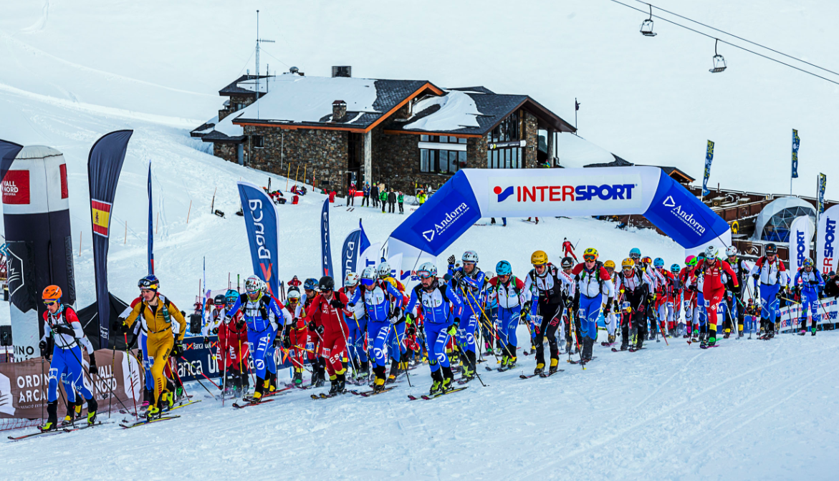
‘Event Name’ 2019

Introduction

The starting point for improving the sustainability of a ski mountaineering race is to understand and analyse, in a systematic and careful way, how environmental factors will affect it from a broad perspective.

The ISMF identifies this phase with the completion of an environmental diagnosis, which will determine and characterize all aspects that may be related to the sustainability of every race, even those over which there is no direct control, but which have an influence all the same.

This is the work document for every ISMF Elite event in terms of sustainability.
Section C is a matrix including a pre-formatted action plan and defining the accomplishment level.

Each LOC must fill out the document as detailed as possible and return it completed to the ISMF Commission of Sustainability by the end of the season.

The more precise your report is, the more efficient and useful our common work will be.

This document is only a starting point, so please let us know if any new items or modifications need to be added within the matrix.

The topic of sustainability is an opportunity to improve in all organisational aspects and will bring many direct and indirect benefits.

For any questions concerning the use of this manual, you can contact sustainability@ismf-ski.org.

- GENERAL INFORMATION
- Basic Information about the event
Insert a Photo of your event
Name of the event | As described in ISMF calendar
Organizer | LOC’s name
Place | City/town, Region, Country
Dates | xx/xx/xx Individual  xx/xx/xx vertical
Number of competitors | Total competitors in all competitions and categories
Number of Staff | Total Volunteers and Professionals
Sustainability área | Name, Tel and mail

- Economical Report
It’s important for LOCs and ISMF to achieve economically sustainable events.
Even if it’s not compulsory, we appreciate it if you can detail the following information:
- Budget of the event per areas
- Final financial result

- Effects on Natural Habitat, Fauna and Flora
Please describe:
- The effects on habitats of natural interest and on populations of species of fauna and flora.
- Mapping of circuits containing information about the course (departure / arrival, refreshments, places of change, natural hazards, etc.) and about the biodiversity of the area (map of habitats, ecologically sensitive areas, etc.)
- A word of advice: you should contact your competent administration in terms of habitats conservation -they should be able to provide you with plans opinions on the race routes.

- C. Action Plan & Evaluation Matrix
- Circuit
Add any complimentary information and photos and detailing procedures, human and economic resources, deadlines, concerning the plans for:
- Marking
- Clearing-up
- Securing the areas (Race and public)
Planned Accomplishment
Action | Planned | Indicator | Accomplishment  Level | Comments
Vertical Signals
Limit the use of fungible material to that which is strictly necessary. | Yes |  | ??
Ensure proper anchorage to prevent dispersal in strong winds. | Yes |  | ??
Before the competition, monitor the status of the environment (photographs at checkpoints, inventory of banners installed) | Yes |  | ??
Re-use signs for subsequent races. | Yes |  | ??
Use colour ties and flanges (preferably black) to stop them from getting lost in the snow. | Yes |  | ??
Limit advertising banners to points of departure and arrivals. | Yes |  | ??
Review and collect methodically all material when the race is finished. | Yes | kg of waste | ??
Snow marking
Choose an organic based dye or alternative to aniline. | Yes |  | ??
Do not mix aniline with antifreeze (alcohol or other industrial liquids). | Yes |  | ??
Safety
It is preferable that the metal plaques are in black stainless steel to avoid the effects of reflection and facilitate their visibility in the snow. | Yes |  | ??
Retrieve anchors and other equipment that are removable. | Yes |  | ??
Opt for lower impact explosives (Ex. Goma-2 ECO, does not contain DNT and reduces emissions of nitrogen oxide and CO2 by almost 70%). | Yes |  | ??
Rationalise the amount of explosives and limit the number of detonations to those that are strictly necessary. | Yes | Quantity of Detonations  Explosives | ??
Cleaning and recovery of waste from explosions (fuse ends, cables, etc.) if needed. | Yes | Kg of waste | ??
Waste
Set penalties for competitors if they leave waste during a race (rules). | Yes |  | ??
Provide and inform about selective waste collection points at refreshment stations on the course and ensure that these points are located in easily accessible areas. | Yes |  | ??
Check the status of the environment before the competition (photographs to compare after the event). | Yes |  | ??
Provide volunteers and members of the organisation with waste collection bags. | Yes |  | ??
Methodical review and collection once the race has finished. | Yes | Kg of waste | ??
Spectators
Provide areas to concentrate the public and prevent the dispersion of people around the circuit. | Yes |  | ??
Installation and information about selective waste collection points (can use existing if it is a ski resort). | Yes | Kg of total waste | ??
Provide volunteers and members of the organization with waste collection bags. | Yes |  | ??
Methodical review and clean up once the race has been completed. | Yes | Kg of waste | ??
Control the volume of stereos so as not to exceed the legal or recommended limits (70 decibels). | Yes | Decibels | ??

- CATERING AND REFRESHMENTS
Add any complimentary information and photos and detailing procedures, human and economic resources, deadlines, concerning the plans for:
- Refreshment areas and caterings (quantity, locations, hours …)
- Composition of meals (packaging, origin of food and beverages, suppliers …)
- Fungible and re-usable materials (dishes, glasses, napkins, …)
- Waste and procedures for his management (collection of fractions, waste destination …)

Action | Planned | Indicator | Accomplishment  Level | Comments
Refreshment points
Prevent food waste. Careful planning and optimization of the preparation and serving of the right amounts of food, as well as care and control of the proper conservation of raw materials, in all refreshment points. | Yes | Kg of food waste | ??
Serve food in bulk (no packaging). | Yes |  | ??
Avoid pods and choose large formats for drinks and food. | Yes |  | ??
Use reusable cups for drinks (avoid disposable plastic cups). | Yes |  | ??
Choose products from local production and organic products or those with eco certification. | Yes |  | ??
Installation of selective waste collection points in fractions. | Yes | total kg of waste | ??
Subsequent transportation to collection points (containers, eco points). | Yes |  | ??
Subsequent clearing of possible waste dumping, if applicable. | Yes | Kg of waste | ??
CATERING
Prevent food waste. Careful planning and optimization of the preparation and service of the right amounts of food, as well as care and control of the proper conservation of raw materials. | Yes | Kg of food waste | ??
Choose local products and suppliers. | Yes |  | ??
Choose products from organic production or those with eco certification. | Yes | % of  eco certified products | ??
Avoid pods (sugar, salt, sauces, coffee capsules, etc.) and opt for large formats for food and drinks. Avoid products with unnecessary wrapping and packaging. | Yes | kg of packaging waste | ??
Avoid bottled water - opt for tap water. | Yes |  | ??
Avoid disposable plastic products (cutlery, glasses, plates, etc.) – Use reusable dishes and glasses. | Yes |  | ??
Installation and information on selective waste collection points. | Yes | Total kg of waste | ??
Subsequent transportation to waste collection points (containers, eco points). | Yes |  | ??
If necessary, distribution of leftover food to charities. | Yes |  | ??

- Event Areas
Add any complimentary information and photos and detailing procedures, human and economic resources, deadlines, concerning the plans for every used area (dinning rooms, press rooms, meeting rooms, changing rooms …) collecting the following information:
- Lighting: Number and type of lights/bulbs used, hours of operation, Kw of Electricity consumption…
- Air conditioning: Type, consumption of HVAC System …
- Water: type of water outlets, estimation of the consumption …
- Cleaning: Description of the service (timetables, products, …)
- Waste management: Fractions to be collected, Estimated quantities, final destination …

Action | Planned | Indicator | Accomplishment  Level | Comments
Choice of event areas
Prioritising local areas with the proper dimensions for race activities (capacity, etc.). | Yes | Kg of food waste | ??
Prioritising areas and services (hotels, catering, etc.) that have eco certificates or have an environmental policy. | Yes | % of certified establishments | ??
Define and provide the necessary means to carry out selective waste collection (all key fractions) from all the areas where activities of the event are being held (press, outdoor areas, etc.). | Yes |  | ??
Adaptation of Areas
Implementation of signposts informing the public about the best environmental procedures to follow (container location, best practices, etc.). | Yes |  | ??
Areas cleaning
Opting for companies certified (ISO, EMAS, …) committed to sustainable cleaning.  - Avoid the use of toxic or potentially polluting products.  - Use eco labelled and natural products rather than synthetic chemicals.  - Logical use of water and chemicals. | Yes | % of eco certified products  Volume of products used | ??
Check the proper management of waste by cleaning companies (that the separation of waste is respected and transferring to the correct destination) or the declaration of environmental responsibility of the company. | Yes | total kg of waste | ??
Energy
Plan in advance and distribute accurately only the air conditioning and lighting equipment which is strictly necessary. | Yes | Power consumption (kW) | ??
Make sure to disconnect unnecessary lighting, electronic equipment and air conditioning in areas after use. | Yes |  | ??

- Communication
Add any complimentary information and photos and detailing procedures, human and economic resources, deadlines, concerning the plans for communication and promotion of the event collecting the following information:
- Type and quantity of material
- Distribution method, …

Action | Planned | Indicator | Accomplishment  Level | Comments
Internal Documentation
Minimise the production of printed materials using digital alternatives (mail, cloud, USB stick, etc.). | Yes | Number of printed sheets (or kg) | ??
In case of printed material, use recycled or eco certified paper for printing (chlorine-free or recycled) and use double-sided option. | Yes |  | ??
Advertising material
Minimise the production of printed material. opt for digital advertising. | Yes |  | ??
If any printed material is produced, choose suppliers who ensure that printing is done using eco certified paper. | Yes | Quantity of printed materials (or kg) | ??
Merchandising
Opt for local products (traditional) or eco certified value-added products. | Yes | - % of eco certified products  - Kg of waste generated (packaging) | ??
Images & video productions
Use drones for audio-visual recordings in place of helicopters. | Yes |  | ??

- Mobility
Add any complimentary information and photos and detail procedures, human and economic resources, people involved, deadlines, concerning the plans for mobility and collect the following information
For each of the 3 areas: Logistics and Security, Volunteers, Spectators
- Overview of the procedures
- Estimated vehicles
- Quantity of trips (km)

Action | Planned | Indicator | Accomplishment  Level | Comments
Logistics & Security
Helicopter: plan flights rationally and minimalise the number of trips, routes, timetables, … | Yes | Nº of flights or fuel consumption | ??
Plan transportation with groomers and snowmobiles to reduce the number of runs and improve efficiency. | Yes | Km travelled or fuel consumption | ??
People transportation with groomers and snowmobiles avoiding traveling in sensitive areas or outside circuit. | Yes |  | ??
Transportation with groomers and snowmobiles as far as possible, choose petrol or electric vehicles instead of diesel (more polluting). | Yes | % of vehicles according to category | ??
As far as possible, choose cleaner vehicles (electric, hybrid) petrol instead of diesel (more polluting) to carry out the mobility. | Yes | % of vehicles according to category | ??
Participants, Volunteers and Professionals
Mobility planning. | Yes | Km travelled or fuel consumption | ??
As far as possible, choose cleaner vehicles (electric, hybrid) petrol instead of diesel (more polluting) to carry out the mobility of people in the organisation. | Yes | % of vehicles according to category | ??
Promote vehicle sharing experiences. | Yes | Number of private  Vehicles  % people using shared transport | ??
Implementation of public transport. | Yes | % of people using public transport | ??
Public
Promote the use of public transport to reach the race areas. | Yes | Number of private  Vehicles  % people using public transport | ??

- Social Responsibility
Add any complimentary information and photos and detail procedures, human and economic resources, people involved, deadlines, concerning the plans for any social associated action and describe the actions in:
- CO2 Offsetting
- Contribution to environmental or charity projects
- Comunication and environmental plan in education platforms
- Others

Action | Planned | Indicator | Accomplishment  Level | Comments
Making a communication plan for environmental awareness. | Yes |  | ??
Promotion and participation in environmental projects and initiatives and /or charities. | Yes |  | ??
CO₂ Offsetting
Calculate event CO₂ emissions and compensate it preferrably via an International Label. | Yes
Propose to the teams and racers to compensate for their CO₂ travel emissions. | Yes | Tons of CO₂ | ??
Propose to spectators coming from outside regions to compensate for their CO₂ travelling emissions. | Yes

- Conclusions & Goals for next editions
      - LOC Global auto-evaluation
Describe a global impression, difficulties found and good experiences concerning the sustainability implementation.
Make a global projection for future editions.

Name Name
LOC President LOC Sustainable Area responsible
Signature Signature

      - ISMF Global commentaries (reserved to ISMF Sustainable Commission)
Resume table per section considering the matrix responses.
Modify data in the graphics and get your values (Report values in Excel associated blue table).
Report calculated Values into table.

Chapter | Declared Intention | Achievement Evaluation
Totals | $$\frac{\sum{Planned=Yes}}{Total items-\sum{Planned=DNA}}$$  Reported in % format | $$\frac{\sum{level}*0,5}{Total items-\sum{Planned=DNA}}$$  Reported In % format
      - Circuit
      - Catering & Refreshment points
      - Event Areas
      - Comunication
      - Mobility
      - Social Responsibility
Global

Any commentary or recommendation by the ISMF Sustainability Commission in the clear objective to improve organization’s quality.

Name Name
ISMF General Manager ISMF Sustainability commission
Signature Signature

